KEY PEOPLE – Ancient Egypt Jigsaw Activity

**Amenhotep III (reigned c. 1386 BCE – 1353 BCE)**

Ah-men-HO-tep

Amenhotep III was the father of Amenhotep IV, later known as Akhenaten. He ruled over a prosperous and stable Egypt, known for his extensive building projects and diplomatic efforts.

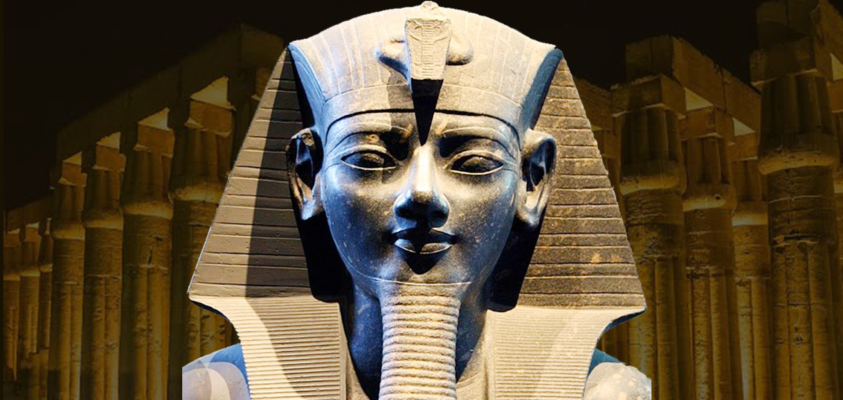

KEY PEOPLE – Ancient Egypt Jigsaw Activity

**Queen Tiye**

Tee-yay

Tiye was the Great Royal Wife of Amenhotep III and the mother of Akhenaten. She wielded significant influence at court and played a role in shaping her son's reign and religious beliefs.

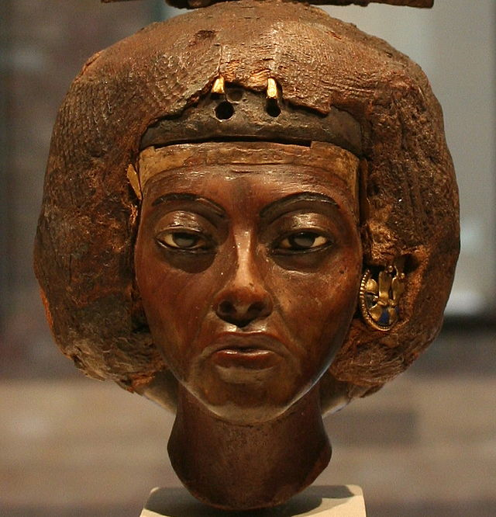

KEY PEOPLE – Ancient Egypt Jigsaw Activity

**Akhenaten (reigned c. 1353 BCE – 1336 BCE)**

Ahk-en-AH-ten

Originally named Amenhotep IV, Akhenaten is best known for his radical religious reforms, which focused on the worship of Aten, the sun disc. He moved the capital to Akhetaten (modern-day Amarna) and instituted monotheistic worship, disrupting traditional Egyptian religious practices.

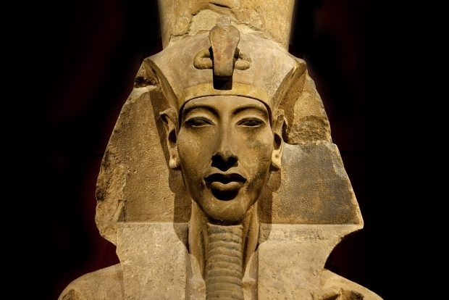

KEY PEOPLE – Ancient Egypt Jigsaw Activity

**Nefertiti**

Nef-er-TEE-tee

Nefertiti was Akhenaten's Great Royal Wife and played a prominent role in the religious and artistic developments of the Amarna Period. She is often depicted alongside Akhenaten in artwork, indicating her elevated status.

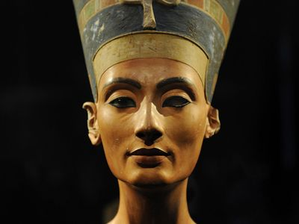

KEY PEOPLE – Ancient Egypt Jigsaw Activity

**Smenkhkare**

S-menkh-KAH-reh

Smenkhkare is a mysterious figure who may have been a co-regent or successor to Akhenaten. His exact relationship to Akhenaten and the nature of his reign remain uncertain.

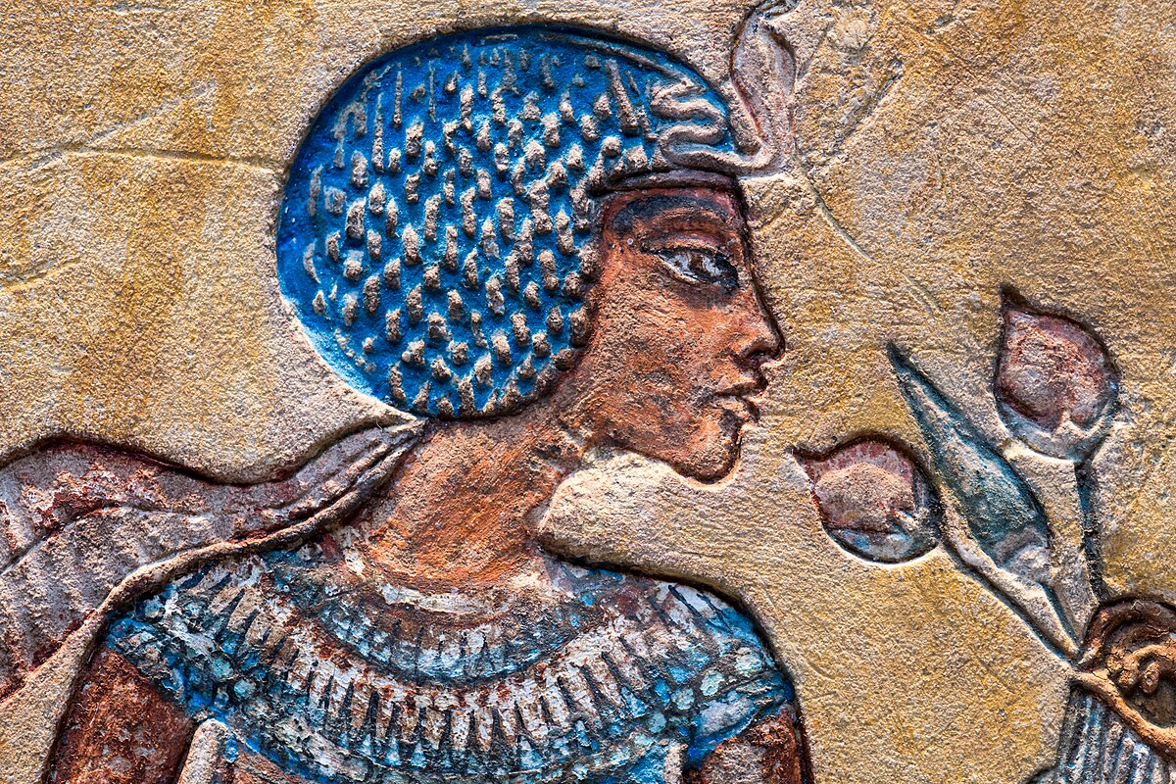

KEY PEOPLE – Ancient Egypt Jigsaw Activity

**Tutankhamun (reigned c. 1336 BCE – 1325 BCE)**

Too-tahn-KAH-muhn

Tutankhamun, originally named Tutankhaten, succeeded Akhenaten and reversed many of his predecessor's religious reforms. He is best known for the discovery of his intact tomb in the Valley of the Kings, which provided valuable insights into ancient Egyptian burial practices.

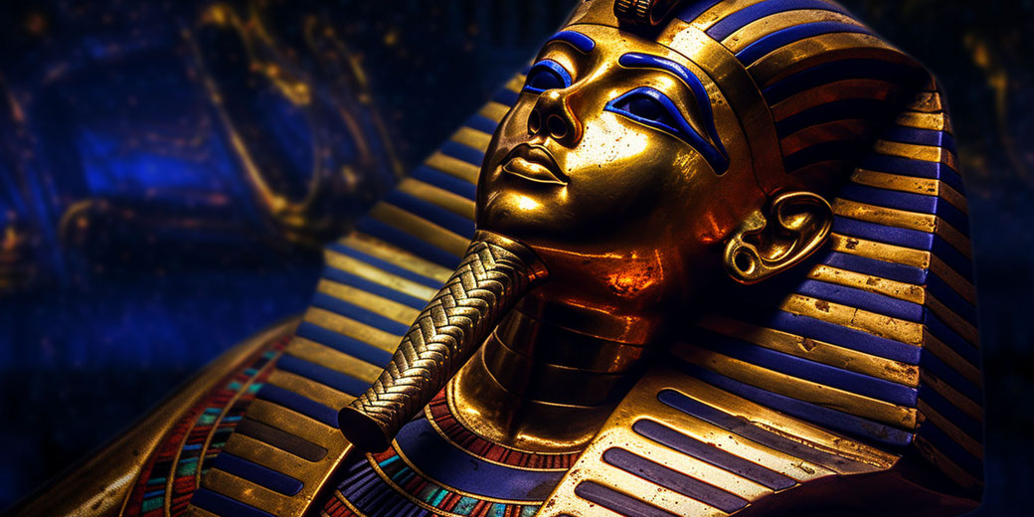

KEY PEOPLE – Ancient Egypt Jigsaw Activity

**Ay**

Eye

Ay served as a high-ranking official under both Akhenaten and Tutankhamun. After Tutankhamun's death, Ay assumed the throne, marrying Tutankhamun's widow, Ankhesenamun, and ruling as pharaoh for a brief period.

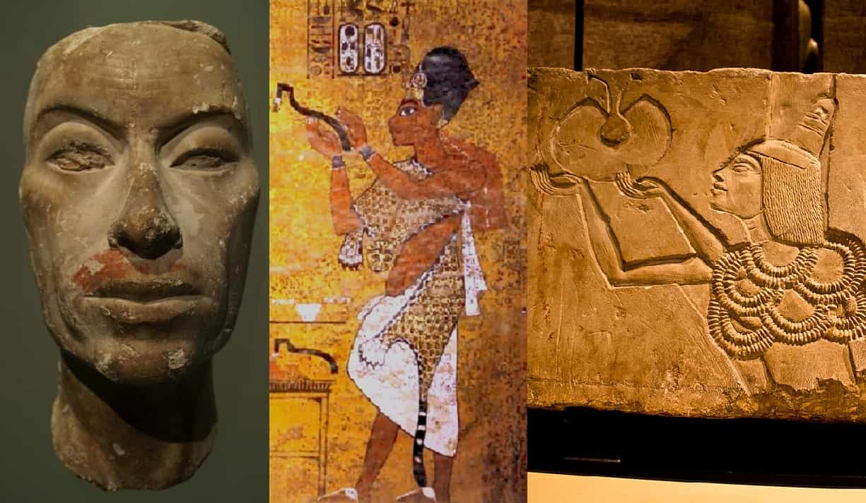

KEY PEOPLE – Ancient Egypt Jigsaw Activity

**Horemheb (reigned c. 1325 BCE – 1292 BCE)**

Hor-em-HEB

Horemheb was a military commander who rose to prominence during the reign of Tutankhamun. He seized the throne after the death of Ay and initiated reforms to restore stability and centralized authority in Egypt, marking the end of the Amarna Period.

